**Assignment 12.3**

**Problem Statement:**

**Problem Statement**

**● Create a list of tuples, where the 1st element of the tuple is an int and the second**

**element is a string.**

**Example - ((1, ‘alpha’), (2, ‘beta’), (3, ‘gamma’), (4, ‘zeta’), (5, ‘omega’))**

**Solution :**

**import** java.io.FileNotFoundException

**import** java.io.FileReader

**import** java.io.IOException

**object** ScObj1 {

**def** main(args: Array[String]): Unit = {

**val** list1 = List("alpha", "gamma", "omega", "zeta", "beta");

**val** list2 = List(1,2,3,4,5);

**val** tuplelist = list2 zip list1

println(tuplelist)

}

}

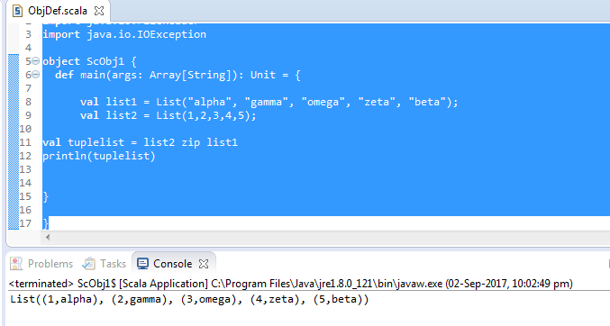

**for the above list, print the numbers where the corresponding string length is 4**

**object** ScObj1 {

**def** main(args: Array[String]): Unit = {

**val** names = List("alpha", "gamma", "omega", "zeta", "beta");

**val** x2= names filter (_.length == 4)

println("Count" + x2.length)

}

}

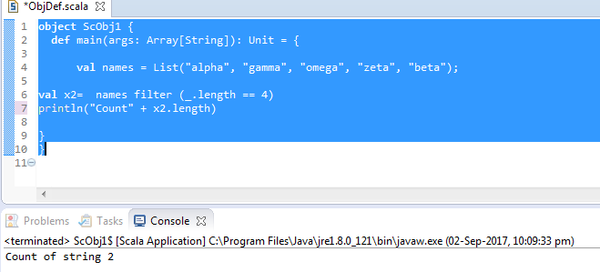

**- find the average of all numbers, where the corresponding string contains alphabet ‘m’**

**or alphabet ‘z’**

**import** java.io.FileNotFoundException

**import** java.io.FileReader

**import** java.io.IOException

**object** ScObj1 {

**def** main(args: Array[String]): Unit = {

**val** names = List("alpha ", "gamma", "omega", "zeta", "beta");

**for**(a <- names)

{

**if**(a.contains("m"))

println(a);

}

}

}